

|  |
| --- |
|  |
| Retail System  REQUEST FOR PRODUCT  CRNOGORsKI TELEKOM |

**CONNECTING YOUR WORLD.**

Imprint

|  |  |  |
| --- | --- | --- |
| Publisher | Author | Filename |
| Crnogorski Telekom | Vladana Mrdak  Ana Djuricanin | RFP Retail System.docx |
|  |  |  |
| Version | Last modified | Status |
| 1.0 | 31.05.2024 | Final |
| 1.1  2.0 | 03.06.2024  18.06.2024 |  |
| Contact | Phone | E-Mail |
| … (Procurement) |  |  |
|  |  |  |
| Short Description | | |
| Crnogorski Telekom searches for a new Retail system that manages all aspects of retail operations, including stock management, sales transactions, financial reporting, to streamline and enhance the efficiency of retail businesses. | | |
|  | | |

Table of Contents

1 Introduction 4

1.1 Scope 4

1.2 Purpose of the document 4

1.3 Intended audience 4

2 Solution Description 5

2.1 User Stories 6

3 Technical description 7

4 Integrations 8

4.1 CT Retail GL postings to OFI 8

4.2 Cost centers, Internal orders, GL accounts master data 11

4.3 WMS interfaces 12

4.4 Product Catalog 16

5 Operational requirements 19

5.1 Deployment & Operating Model 19

5.2 Project Delivery Timeline 19

5.3 Delivery Approach 19

5.4 Security 20

5.5 Laws and Regulations 20

5.6 Data privacy and protection 20

5.7 Service Level Agreement 20

6 References 21

7 Demo 21

8 Glossary and Terminology 22

9 Annex 23

# Introduction

Crnogorski Telekom (CT) as part of Deutsche Telekom AG group operates consumer business market in Montenegro.

Crnogorski Telekom requests a vendor to present its view on an IT solution for a Retail System

## Scope

The scope of Retail system should cover all aspects of retail operations, including stock management, sales transactions and financial reporting.

The new retail system, intended to replace the existing solution, should be designed with flexibility akin to modern IT systems, allowing the company to swiftly adapt to market changes.

## Purpose of the document

Crnogorski Telekom IT will start a request for information (RFP) to find a vendor developing the Retail System. This document will be a vital part of the RFP that:

* Describes the architecture vision and concept.
* Explains the capabilities needed and related user stories.
* Lists functional and non-functional requirements for Retail System.
* Lists of interfaces that have to be integrated with Retail System.

## Intended audience

The document should mainly address possible vendors bidding for the development of the Retail System and its components. The vendor is requested to show a complete IT solution, covering the complete requested architecture. He is allowed to partner for parts of the requested architecture, but needs to take the prime contractor responsibility towards CT IT.

# Solution Description

The proposed solution must be designed to accommodate and maintain all existing functionalities present within the current Retail system. This means that any capability, feature, or process that is currently operational within the Retail system should remain operational, uninterrupted, and unaffected when the new solution is implemented. This includes, but is not limited to, functions like invoicing, stock management, order fulfilment, and other related processes that are inherent to the Retail. The transition to the new solution should ensure there's no loss of functionality, and operations should continue seamlessly, ensuring no negative impact on business processes or customer experience.

Vendor should state its compliance with detailed requirements described in RfP Retail System Requirements.xlsx.

A Retail system should encompass a range of functionalities to efficiently manage various aspects of retail operations:

* **Stock Management**: Keep track of stock levels, manage products, facilitate stock replenishment and manage warehouses. It should be integrated with external WMS system operated by Montenomax company.
* **Point of Sale (POS)**: Process sales transactions, including cash, credit/debit cards, and other payment methods, generate invoices, send invoices to fiscalization, manage returns and exchanges for all types of customers. Manage cash registers.
* **Trade book management**: Manage sales of devices, goods, services and record all trading services for all types of sales.
* **Omni-channel Integration**: Seamlessly integrate sales channels, such as physical stores, e-commerce platforms, and mobile apps, to provide a unified shopping experience for customers.
* It’s role should not be Customer Relationship Management (CRM) as Crnogorski Telekom already operates a system with this purpose, but it should receive and store business customer information, including company details, identification codes, and allow persistent change of these information.
* **Analytics and Reporting**: Generate reports on sales performance, inventory turnover, and other key metrics defined by legislation or internally.

Retail system should accommodate different types of sales and support different workflows for each, such as:

* **Retail sale** - direct sale of devices/goods or services to residential, business or business-residential customers for their personal use.
* **Sale through Partner shops** – In wholesales Partner shop is business customer that sells devices, goods or services of Crnogorski Telekom and the invoice toward partner is issued in moment of sales at partner shop premises. Partner shops have access to CT external CRM system.
* **Wholesale / Sale through dealers** - dealer represent business customer that buys goods/services of Crnogorski Telekom (with rebate) and sells them to end customer. Invoice toward dealer is created in advance.
* **Commission sale** – sale of goods that belong to different company and is not CT stock.
* **Catalogue sale** – sale of goods from different suppliers.

Crnogorski Telekom currently supports 3 types of customers, business, residential and business-residential, and sales can be made to all three. Residential customers are individuals, business customers are companies. Business-residential type of customer is a hybrid type that can be found under company’s hierarchy. This customer type has following characteristics:

* Those customers are eligible for business offer since they are affiliated with certain company.
* They are responsible for payment (not the company).
* They sign individual contract with Telecom (Company is signing contract only for corporate numbers).
* When financial info is sent to SAP, their data is reported in same profit centre as for corporate (business) customers.

In Retail, distinct documents must be generated for each sales category, as the revenue is allocated to different accounts. Customer type information is sourced from the CRM, and it must be accurately mapped in the Retail system to ensure proper posting and transfer to SAP.

Through Retail system it is possible to sell commodities and services as well as bundles. Commodities refer to any good that is on stock, e.g. mobile device or tablet. Example of service would be prepaid replenishment, licenses, etc…

## User Stories

The following user stories should be focus of the Demo presentation:

1 Rotation of user between Business units, with authorisation rights (RFP Retail System Requirements, FR005).

2 Sales of device to business customer, review of process and invoice, preview of warehouse before and after the invoice, overview of Cash register and Trade book (RFP Retail System Requirements, FR059).

3 Sales of device to partner shop (same business customer), review of process and invoice, preview of warehouse before and after the invoice(RFP Retail System Requirements, FR089) .

4 Sales of device to dealer (same business customer), review of process and invoice (with rebates), preview of warehouse before and after the invoice (RFP Retail System Requirements, FR089).

5 Entry of prices for one internal product (stock) - retail price, subsidy price, instalments price(RFP Retail System Requirements, FR028-FR031).

6 Catalogue sales - import of catalogue and prices, sales of this type of products to residential customer in shop, overview of Cash register and Trade book (RFP Retail System Requirements, FR077- FR081).

# Technical description

The vendor should present the roll out plan to assure business continuity with minimal operational risks while conducted, and migration process without any business freeze. CT asks the vendor to show all options for the offered IT solution and the assumed migration risks and factors.

The solution should be designed following a modular approach. This modular architecture should allow for the decomposition of the system into discrete, interchangeable components with well-defined interfaces and functionalities. Each module should be capable of independent development, testing, and maintenance, promoting scalability, flexibility, and ease of future enhancements, benefitting from reusability where applicable.

No single point of failure is required. The system is not allowed to have any component (server, process, module) whose availability of a particular instance is a prerequisite for the availability of the system's services. Any application implementation has to have failover capabilities.

The application must support virtualization and should be agnostic to virtualization technology. Application should be designed and developed in a way that allows it to run effectively within virtualized environments. Cloud-native approach is preferred and it is expected that the application is packaged in containers. Application should support automatic testing and deployment tools.

The components should be designed with "data consistency" and "data integrity" in mind, which means that measures should be put in place to ensure that the data remains accurate and consistent across all components. These design principles can help ensure that the components work together seamlessly and provide reliable and accurate data.

The solution should be designed in a way that allows components to be added, removed, or modified without requiring changes to other parts of the system and should not have "hard-coded dependencies". These design principles can help ensure that the system is flexible and adaptable to changing requirements, and that modifications or updates can be made without causing unintended side effects or breaking the system.

Full business functionality must be available during deployment / upgrade or planned maintenance.

The solution should have a Graphical User Interface for all functions (end-user, operational and administrative). The interface for GUI should be web browser and it should be adapted for all devices (computer, mobile, tablet).

The solution has to be well documented and documentation in Montenegrin / English available to CT.

The solution must be exposed via APIs to enable integration, automation, and third-party development. Comprehensive API documentation must be provided. API should be applicable for either single or mass actions. The required info flows for the offered IT solution must be provided by the vendor; it can be assumed that every required access to data objects is available. An API based or event driven approach should be favoured for a classic point-to-point-based interface architecture. All available business functions must be exposed as RESTful APIs. Integration between own modules should be handled using the exposed APIs. The application needs to handle concurrent requests from various digital channels without encountering problems, such as timeouts or database locks.

Application must be able to support adding custom attributes in APIs without development.

# Integrations

Retail system will be integrated with already existing channels and interfaces as described in picture 1.

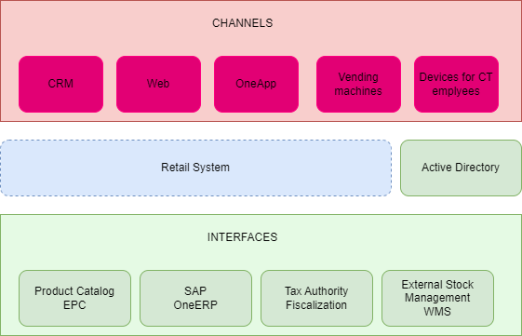

PICTURE 1: Retail Ecosystem

All interfaces are listed in document RfP Retail System Requirements.xlsx, sheet Integration Requirements.

In this chapter, known and fixed interfaces are described to details.

## CT Retail GL postings to OFI

Interface for the transfer of posting data from CT Retail system – GL postings to One.ERP system PFS is described. Sales related data from the Retail system have to be transferred to One Finance on a daily basis to ensure all business transactions are consistent in One Finance.

The customers used in Retail get their master data from One.ERP system EDM. The financial data generated using these customer needs to be transferred to One.Finance on a daily basis.( business customer)

Tax data is also transferred.

Interface must transfer the data daily (both for business customers and shops).

* Business customers (legal entities) open item data is transferred in the form of GL postings. Data transfer should happen daily.
* Retail shops. Every retail shop’s data is transferred to GL accounts, the separation is made base on Payment Method used in Retail system (these are not the payment methods used by OFI). Reason for this is reporting purposes. At the end of every day the sales data is transferred as one accounting document for one GL account per Shop”. Since thousands of sales can happen in one day in one shop, aggregation should be made on Retail side:
  + Every line item should be aggregated if only the value is different, but other parameters are the same within the line items
  + This way it is possible to avoid more than 999 line items in one document.
  + Since the shop itself is already an “aggregated customer”, such aggregation of line items will not result in the loss of business relevant data

IDoc structure FIDCCP02 will be used for interface transfers:



Following fields must be transferred via the interface:

|  |  |  |  |
| --- | --- | --- | --- |
| Name of structure | | Document header (E1FIKPF in IDoc) | |
| Field name | TType | Length | Comment |
| BUKRS | | CCHAR | 4 | Company Code - must be "1384" |
| BLDAT | | CCHAR | 8 | Document date in form "ddmmyyyy". |
| BLART | | CCHAR | 2 | Document type |
| BUDAT | | CCHAR | 8 | Accounting date in form "ddmmyyyy". |
| XBLNR | | CCHAR | 16 | Referencing document |
| BKTXT | | CCHAR | 25 | Document header text |
| WAERS | | CCHAR | 5 | Currency |
| XREF2_HD | | CCHAR | 20 | Interface ID and sender system |

Business Area (GSBER) will not be used by Crnogorski Telekom in OFI.

|  |  |  |  |
| --- | --- | --- | --- |
| Name of structure | | Document GL item (E1FISEG in IDoc) | |
| Field name | Type | Lg. | Comment |
| BUZEI | CHAR | 3 | Line item number |
| BSCHL | CHAR | 2 | Posting Key 40 = GL debit 50 = GL credit |
| HKONT | CHAR | 10 | GL account |
| WRBTR | CHAR | 13 | Amount in document currency (example: 15000,00) |
| MWSKZ | CHAR | 2 | TAX code (must be mapped in Retail) |
| ZUONR | CHAR | 18 | Assignment |
| ZTERM | CHAR | 4 | Terms of payment (on customer line). |
| SGTXT | CHAR | 50 | Item Text: Employee name and phone model number |
| KOSTL | CHAR | 10 | Cost center |
| AUFNR | CHAR | 12 | Internal order |
| XREF3 | CHAR | 20 | Interface ID and sender system |
| PROJK | NUMC | 8 | WBS element (internal) |

The OFI internal WBS numbers will be maintained manually in CT retail (only 2-3 WBS elements).

|  |  |  |  |
| --- | --- | --- | --- |
| **Name of structure** | | **Document customer/vendor item (E1FINBU in IDoc)** | |
| Field name | Type | Lg. | Comment |
| BUZEI | CHAR | 3 | Line item number |
| BSCHL | CHAR | 2 | Posting Key 01 = customer invoice 11 = customer credit memo |
| KUNNR | CHAR | 10 | Customer number |
| WRBTR | CHAR | 13 | Amount in LOCAL currency (example: 15000,00) |
| MWSKZ | CHAR | 2 | TAX code (must be mapped in Retail) |
| ZUONR | CHAR | 18 | Assignment |
| UMSKZ | CHAR | 1 | Special G/L indicator |
| ZTERM | CHAR | 4 | Terms of payment (on customer line). |
| ZLFBDT | CHAR | 8 | Baseline Date |
| ZLSCH | CHAR | 1 | Payment Method |
| SGTXT | CHAR | 50 | Item Text |
| AUFNR | CHAR | 12 | Internal order |
| XREF3 | CHAR | 20 | Interface ID and sender system |

Value Date (BSEG-VALUT) are not used with the interface.

|  |  |  |  |
| --- | --- | --- | --- |
| Name of structure | | Tax item (E1FISET in IDoc) | |
| ***Field name*** | Type | Lg. | Comment |
| BUZEI | CHAR | 3 | Line item number for Tax |
| MWSKZ | CHAR | 2 | TAX code (must be derived) |
| BSCHL | CHAR | 2 | Posting Key: 40 = debit, 50 = credit |
| SHKZG | CHAR | 1 | Debit or credit indicator |
| HKONT | CHAR | 10 | GL account |
| FWSTE | CHAR | 13 | Tax amount (example: 1500,00) |
| XREF3 | CHAR | 20 | Interface ID and sender system |

Above are listed fields that are mandatory but not all data is needed for GL posting interface. All data is covered with FIDCCP02 structure.

**Error handling:**

The following requirements concerning monitoring of the IDoc transfer have to be met:

* IDocs sent from CT Retail have to be transferred to the CT server
* CT Retail has to ensure that documents are not transferred unintentionally multiple times via IDoc, each package needs to have a specific id stored in reference field (BKPF-XBLNR) of the posting
* In the SAP system One.ERP Finance, will be ensured that IDocs are not processed several times which would result in wrong financial values
* In case of errors, nothing should be posted

Example:



## Cost centers, Internal orders, GL accounts master data

Sftp transfer should be used to send data from CT server to Retail system.

Cost center data structure:

| Description | Key field | Mandatory/Optional | Technical name (where checkable) | Data type | Length |
| --- | --- | --- | --- | --- | --- |
|
|  |
| Cost center ID | X | M | ZMP_CCENTER-KOSTL | CHAR | 10 |
| Short name |  | M | ZMP_CCENTER -KTEXT | CHAR | 20 |
| Description |  | M | ZMP_CCENTER -LTEXT | CHAR | 40 |
| Creation date |  | M | ZMP_CCENTER -ERSDA | DATS | 8 |
| Valid to date |  | M | ZMP_CCENTER -DATBI | DATS | 8 |
| Lock indicator for actual primary postings |  | M | ZMP_CCENTER -BKZKP | CHAR | 1 |
| Profit center |  | M | ZMP_CCENTER -PRCTR | CHAR | 10 |
| Company code |  | M | ZMP_CCENTER -BUKRS | CHAR | 4 |
| Person responsible |  | M | ZMP_CCENTER -VERAK | CHAR | 20 |
| CRC check |  |  |  | CHAR | 20 |

File name: EDM_ktgh.com.TXT

Example:



Selection will be restricted to company code, so CT based cost center will be distributed to Retail ( Company code = “1384”)

Internal order data structure:

| EN description | Provided  in the file {Mandatory} | Type | Length | SAP field |
| --- | --- | --- | --- | --- |
| Order number | yes | char | 12 | AUFK-AUFNR |
| Description | yes | char | 40 | AUFK-KTEXT |
| Creation date | yes | char | 8 | AUFK-ERDAT |
| Date of last change | yes | char | 8 | AUFK-AUDAT |
| Release date | yes | char | 8 | AUFK-IDAT1 |
| Technical completion date | yes | char | 8 | AUFK-IDAT2 |
| Close date | yes | char | 8 | AUFK-IDAT3 |
| Status opened | yes | char | 1 | AUFK-PHAS0 |
| Status released | yes | char | 1 | AUFK-PHAS1 |
| Status technically closed | yes | char | 1 | AUFK-PHAS2 |
| Status closed | yes | char | 1 | AUFK-PHAS3 |
| Responsible cost center | yes | char | 10 | AUFK-KOSTV |
| Company code | yes | char | 4 | AUFK-BUKRS |
| External order number | yes | char | 20 | AUFK-AUFEX |
|  |  |  |  |  |
| CRC check |  | char | 20 |  |

File name: EDM_rend.com.TXT

Example:



Selection will be restricted to company code, so CT based internal orders will be distributed to Retail ( Company code = “1384”)

GL account data structure:

| EN description | Provided in the file {mandatory} | Type | Length | SAP field |
| --- | --- | --- | --- | --- |
| GL account number | yes | char | 10 | SKA1-SAKNR |
| GL account short text | yes | char | 20 | SKAT-TXT20 |
| GL account long text | yes | char | 50 | SKAT-TXT50 |
| Creation date | yes | char | 8 | SKA1-ERDAT |
| Blocked | yes | char | 1 | SKA1-XSPEB |
| Balance sheet account | yes | char | 1 | SKA1-XBILK |
| CRC check | yes | char | 20 |  |

File name: EDM_fkv.com.TXT

Example:



GL account cannot be restricted, all GLs in SAP system will be distributed to Retail.

Code page is ISO-8895-2

## WMS interfaces

WMS interfaces are interfaces between WMS and Retail system, related to the transfer between central warehouse locations and other Retail locations, as well as issuing to dealers.

Interfaces:

1. Delivery order to Dealer and Shops ( SO Import)
2. Delivery confirmation for Dealer and Shops ( SO Export)
3. Return order from Dealer and Shops to Central Warehouse ( ASN Import)
4. Delivery Confirmation for Return order from Central Warehose( ASN Export)
5. Acknowledge file

Each of the interfaces should have a set of error messages, as well as a way to correct them.

Each order should receive an automatic unique number and the requested delivery date should be set automatically to the next business day. The unique number from the order and the number of the intermediate warehouse or delivery note should be in the file for transfer to WMS.

It should be possible to control the creation of intermediate warehouses, eliminate the possibility of cloning (creating several intermediate warehouses under the same number).

Interfaces file structure:



Examples:

   

Use Cases:

1. Use case Title: Delivery order to Shops

Description: This use case describes the process of issuing materials to shops

Goal: Transfer of materials from the Central warehouse to the shop warehouses through the WMS interface Frequency: Processes for export/import of documents are started every 5 minutes

Folders: SOImport, SOExport (SOImport/Com, SOImport/bck, SOExport/Com, SOExport/bck)

Delivery order to Shops:

1. Delivery order is created in Retail

2. By saving the Delivery order, an MSKI (outgoing) document from the Retail Central Warehouse to the shop's warehouse is created, an MSKU (incoming) document to the shop's warehouse from the Retail Central Warehouse is created, as well as an interface file are automatically created according to the SOImport structure

3. The status of the MSKI document is Closed and the quantities of materials (document items) are automatically reduced in the Central Retail warehouse, while the status of the MSKU document is Created

4. The interface file (delivery order) is sent to the CT MQ server and placed in the SOImport/com folder. The number of each document is unique and contains the external reference document number from CTR and the time of sending in the format YYYYMMDD_HHMM

5. After a successful upload, the WMS interface downloads the Issue Order from the CT MQ server and archives it to the WMS related server , and moves it to the SOImport/bck folder on the CT MQserver

6. The quantities of materials from the Delivery Order are physically sent from the Montenamax Central warehouse to the shop's warehouse. ( Montenomax is Partner responsible for WMS)

7. A WMS document is created on the confirmation of the delivery order with status 3 - Delivery completed, is sent via the interface to the CT MQ server and placed in the SOExport/com folder, which is uploaded to the Retail database and after successful uploading, it is moved to the directory SOExport/bck

8. With the physical receipt of materials in the shop's warehouse, Retail closes the MSKU document (status Closed) and increases the quantity of materials received in the shop's warehouse, thus completing the process

9. Using the interface, send to the SOImport/com folder, according to the same structure, an identical file as in the delivery order, where the mandatory fields are REF_DOC_NO and DOC_DATE

10. By importing this file into WMS, the realized delivery time on the order is updated.

1. Use case Title: Cancellation from Retail

1. Through Retail, the Delivery order is reversed, which automatically reverses the MSKI (outbound) document from the Retail Central warehouse to the shop's warehouse (quantities are returned to the Retail Central warehouse) and the interface file (delivery order) according to the SOImport structure

2. The canceled delivery order (a file identical to the issuance order, with status 4 - Canceled) is sent to the CT server and placed in the SOImport/com folder

3. The WMS interface loads the reversed Delivery Order from the CT server and archives it to the server in Montenomaks and moves it to SOImport/bck on the CT MQ server

1. Use case Title: Cancellation from WMS

1. Delivery order is created in Retail

2. By saving the Delivery order, an MSKI (outgoing) document from the Retail Central Warehouse to the shop's warehouse is created, an MSKU (incoming) document to the shop's warehouse from the Retail Central Warehouse is created, as well as an interface file are automatically created according to the SOImport structure

3. The status of the MSKI document is Closed and the quantities of materials (document items) are automatically reduced in the Central Retail warehouse, while the status of the MSKU document is Created

4. The interface file (delivery order) is sent to the CT MQ server and placed in the SOImport/com folder. The number of each document is unique and contains the external reference document number from CTR and the time of sending in the format YYYYMMDD_HHMM

5. After a successful upload, the WMS interface downloads the Issue Order from the CT MQ server and archives it to the WMS related server , and moves it to the SOImport/bck folder on the CT MQ server

6. The delivery order is canceled by creating an interface file on the confirmation of the delivery order with status 4 - Canceled, which is sent via the interface to the CT MQ server and placed in the SOExport/com folder, which is uploaded to the Retail database via IT. We need to know why done undone by WMS (which items)

7. Through Retail, the MSKI document is reversed and the quantities of material from the reversed document are returned to the Retail Central Warehouse, thus the order reversal process is completed.

1. Use case Title: Delivery order for Dealers

Description: This use case describes the process of issuing materials to dealers

Objective: Transfer of materials from the Central warehouse to the dealers' warehouses through the WMS interface

Frequency: Processes for export/import of documents are started every 5 minutes

SOImport, SOExport folders (SOImport/Com, SOImport/bck, SOExport/Com, SOExport/bck)

The basic flow is identical to the basic flow of the delivery order process for T-Centres, with the fact that the output document that is created is not MSKI but KONR (Consignment Debt), and the input document is not MSKU but KONZ (Consignment Debt).

1. Use case Title: Cancel order for Dealer

Cancel of orders through WMS and through Retail are identical to flows of the delivery order cancel process for T-Centres, with the fact that the output document that is created is not MSKI but KONR (Consignation clearance). and the entry document is not MSKU but KONZ (Consignment Obligation).

1. Use case Title: Return order from Shops

Description: This use case describes the process of the planned return of goods from storage locations from Shops to the Central warehouse.

Goal: Return of goods from warehouse locations from Shops to the Central warehouse through the WMS interface

Frequency: Processes for export/import of documents are started every 5 minutes

Folders: ASNImport, ASNExport (ASNImport/Com, ASNImport/bck, ASNExport/Com, ASNExport/bck)

1. In Retail, an MSKI (outgoing) document is created from the warehouse location to the Retail Central warehouse

2. Closing the output document (status Closed) automatically reduces the quantities of materials (document items) in the warehouse, creates an MSKU (input) document for the Retail Central warehouse with the status Created and an interface file about the receipt announcement

3. The notification of receipt is sent to the CT MQ server and placed in the ASNImport/com folder. The number of each document is unique and contains the external reference document number (Reference Document Number) from CTR, the time of sending in the format YYYYMMDD_HHMM and the planned_return flag is set to 1

4. The WMS interface loads the receipt notification document from the CT MQ server and archives it on the server in Montenomaks and on the CT MQ client, after the successful loading of the transfer to ASNImport/bck

5. The quantities of materials from the receipt announcement document are transported from the storage location to the Montenamax Central Warehouse

6. After the physical receipt of the material in the Montenamax Central Warehouse, a receipt confirmation document is created with the status 3 - Delivery completed, it is sent via the interface to the CT MQ server and placed in the ASNExport/com folder, which is uploaded to the Retail database via informatics and after successful uploading move to ASNExport/bck

7. With the confirmation of receipt, the MSKU document is closed through Retail (status Closed) and the quantities of received materials are increased at the Retail Central warehouse, which completes the process.

1. Use case Title: Cancellation from Retail

1. In Retail, the MSKI (outbound) document is reversed (quantities are returned to the outbound warehouse) and the interface file Notification of Receipt

2. The canceled order (a file identical to the order for the announcement of receipt, with status 4 - Canceled) is sent to the CTserver and placed in the folder SOImport/com

3. The WMS interface loads the reversed order from the FTP server and archives it to the server in Montenomaks and moves it to SOImport/bck

1. Use case Title: Cancellation from WMS

1. In Retail, an MSKI (outgoing) document is created from the warehouse location to the Retail Central warehouse

2. Closing the output document (status Closed) automatically reduces the quantities of materials (document items) in the warehouse, creates an MSKU (input) document for the Retail Central warehouse with the status Created and an interface file about the receipt announcement

3. The notification of receipt is sent to the CT MQ server and placed in the ASNImport/com folder. The number of each document is unique and contains the external reference document number (Reference Document Number) from CTR, the time of sending in the format YYYYMMDD_HHMM and the planned_return flag is set to 1.

4. The WMS interface loads the receipt notification document from the FTP server, archives it to the Montenomax server, and moves it to ASNImport/bck on the MQ server.

5. The announcement of receipt is canceled by creating a document confirming receipt for delivery with status 4 - Canceled, which is sent via the interface to the CT MQ server and placed in the folder ASNExport/com, which is uploaded to the Retail database through IT and moved to ASNExport/bck

6. In Retail, the MSKI document is reversed, the quantities of material from the reversed document are returned to the storage location, thus the order reversal process is completed

1. Use case Title: Return order from Dealers

Description: This use case describes the process of a return of goods from dealer warehouse locations to the Central warehouse

Objective: Return of goods from dealer warehouse locations to the Central warehouse through the WMS interface

Frequency: Processes for export/import of documents are started every 5 minutes

Folders: ASNImport, ASNExport (ASNImport/Com, ASNImport/bck, ASNExport/Com, ASNExport/bck)

The basic flow is identical to the basic flow of the goods return process for Shops, with the fact that the output document that is created is not MSKI but KONR (Consignment Debt), and the input document is not MSKU but KONZ (Consignment Debt).

1. Use case Title: Cancel return order for Dealers

Cancel of return orders through WMS and through Retail are identical to flows of the goods return cancel process for Shops, with the fact that the output document that is created is not MSKI but KONR (Consignation settlement ), and the input document is not MSKU but KONZ (Consignation Obligation).

ERROR PROCESSING

Feedback on the import of interface files from Retail to WMS

IN_WMS_ACK file is sent to the CT MQ server and uploaded to Retail. Errors sent to IN_WMS_ACK files are sent to the mail of the responsible person.

The CT user will be able to manually start the process of sending the interface file both from Retail and from WMS. (In the event that the file is not automatically sent).

## Product Catalog

Enterprise Product Catalog is Product Catalog in CT IT ecosystem. It centralizes and manages detailed product information, ensuring consistency across multiple sales channels. It supports advanced search and filtering, dynamic pricing, and personalized recommendations, while integrating seamlessly with CRM, Ordering, and other third-party systems.

At the same time, certain entities need to exist and be maintained in Retail system. In order to maintain single mastership of data regarding devices, goods, prices and packages, interfaces should exist while populating each of the entities so that the data is synchronized between Retail system and Enterprise Product Catalog.

Next pictures describe data flow for different entities in Retail towards and from different external systems, such as SAP and EPC. M stands for Mandatory, while O stands for Optional.

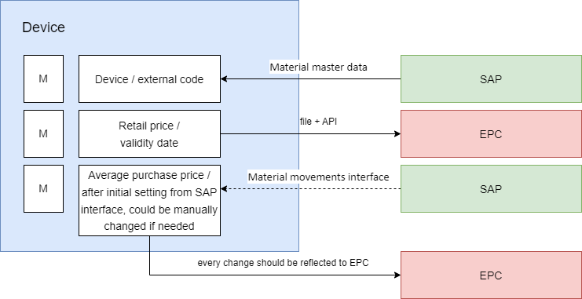

Picture 2. Device definition and data flows

The application needs to support the following features for Goods entity as described in Picture 3:

* Importing Goods Parameters from Excel: Users can upload an Excel file containing Goods parameters.
* Real-time API Updates: When changes are made to Goods (either individually or in bulk), the application should immediately reflect these changes in an external system by making API calls.
* Exporting Prepared Excel Files: Users should be able to extract an Excel file with a specific format, ready for import into the external system.

Picture 3. Goods definition and data flows

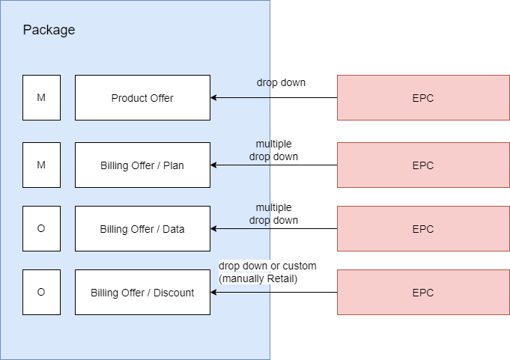

Picture 4. Package definition and data flows

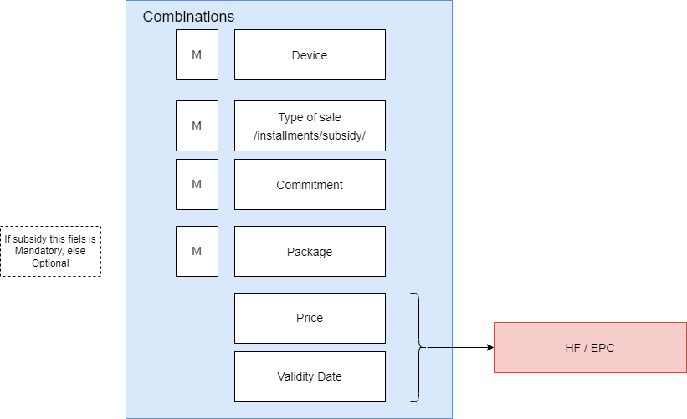

Picture 5. Combinations definition and data flows

# Operational requirements

## Deployment & Operating Model

Vendor should propose hardware necessary to support the solution as well as required 3rd party software.

The proposed solution should be designed to support the following nonfunctional requirements:

* Application must be hosted on premise in Crnogorski Telekom Data Center.
* Application and all the components in scope should be cloud native.
* The production system must be highly available with no single point of failure.
* Application architecture should be designed for scalability to meet changing demands and minimize downtime.
* All proposed HW and 3rd party software should be supported and actively maintained.
* Virtualization must be supported and should be agnostic to virtualization technology. Application should be designed and developed in a way that allows it to run effectively within virtualized environments.
* Test and development systems should be production-like.
* The solution should have a Graphical User Interface for all functions (end-user, operational and administrative). The GUI interface should be via web browser.

The vendor should describe available deployment and operating models for the offered IT solution. Cloud native model that includes deployments in a private cloud hosted in Crnogorski Telekom is preferred option.

RACI Matrix should be proposed by Vendor and aligned with CT.

## Project Delivery Timeline

The proposed project delivery timeline is illustrated in the image below.

## Delivery Approach

Due to fast developing market and dynamic changes of the requirements of Crnogorski Telekom retail customer operations, the project needs to be as Agile as possible, i.e. ongoing changes of the scope are expected.

The core development team(s) has/have to work onsite in Podgorica at CT IT with a cross-functional team, i.e. Developers, Testers, Designers, etc. We expect team(s) to be stable throughout development for effectiveness reasons.

We expect the vendor to define the supporting roles and infrastructure needed from Crnogorski Telekom to successfully deliver its work. Furthermore, we expect the vendor to define the number of needed team(s) and their size(s). Finally, we expect a kind of release plan with number of necessary sprints.

The vendors should show multiple options how he will setup his workforce and teams to support and implement his offered IT solution, i.e. show possible nearshore and offshore setups.

Vendors must formulate a practical migration strategy and oversee its implementation. Additionally, the vendor is obligated to configure the environment to allow both BSS platforms to operate concurrently.

## Security

The Retail System should offer sufficient privacy and security by e.g. supporting appropriate security standards and implement security measures to protect sensitive data, such as customer information and payment details, and ensure compliance with relevant regulations, such as PCI DSS (Payment Card Industry Data Security Standard).

The vendor must offer an IT solution which complies to Information Security Annex and PSA - Privacy and Security Assasement procedure. Crnogorski Telekom security standards are provided to the vendor in their actual versions via a separate document.

The Crnogorski Telekom security requirements are defined by the additional documents submitted within the file “DTAG_Security_Requirements.zip”.

## Laws and Regulations

The vendor must offer an IT solution which complies to Crnogorski Telekom legal and regulation standards.

SLA should include changes to the system conditioned by legal changes.

## Data privacy and protection

The vendor must offer an IT solution which complies to Crnogorski Telekom and state of Montenegro data protection laws and standards and “DTAG_Privacy_Requirements.zip”.

## Service Level Agreement

The Service Level Agreement is the measurable description of the services owed by the Vendor to the Ordering Party for quality assurance and the provision of maintenance and repair services during the implementation of the “Retail system” as well as the post-launch operations.

The vendor is requested to detail the range of services encompassed within their support offerings. Various support categories and their respective levels should be specified. SLA is proposed for review and mutual agreement in following table.

|  |  |  |  |
| --- | --- | --- | --- |
| Incident severity | Description | Response Time | Resolution Time |
| Critical | Application is down. | 15 minutes | 1 hour |
| Application is not able to communicate with critical external Application. |
| Critical external Application is not able to communicate with the Application. |
| Core Application component is not operational. |
| Critical security issues affect the Application. |
| Major | Application is operational but some non-core components are down. | 2 hours | 4 hours |
| Application component is operational, but it doesn't work as designed. |
| Load to Application disrupts normal operations. |
| Data corruption on Application disrupts normal operations. |
| High-priority requests for information and technical queries. |
| Moderate | Reduced operability in business processes in the production environment. | 1 day | 3 days |
| Non-critical errors or operational problems. |
| Regular requests for information and technical queries. |
| There is a need to check or upgrade application or any of its components. |
| Requests to provide support during works of other systems. |
| Minor | Cosmetic errors and changes. | 2 days | 7 days |
| Minor problems and requests |
| Documentation anomalies and requests. |
| Various low-priority requests for information and technical queries. |

# References

The vendor is asked to show respective references showing successful deployment of the offered IT solution in Retail industry business. Shown reference should be live references and should be of respective size and business setup to Crnogorski Telekom A.D. retail customer business.

Vendor needs to enclose up to 4 references as proof that this condition is fulfilled. Each reference needs to contain value, period and characteristics of the project implemented. Contact to these references must be possible at short notice.

# Demo

The purpose of the demo is to get a better understanding of how the solution works and what its features and benefits are. By seeing the solution in action, Crnogorski Telekom can assess its potential value and check whether it meets its needs and requirements. Additionally, a demo can help to establish trust and confidence in the solution provider, as it shows that they are transparent and confident about the capabilities of their product or service.

The vendor is asked to present his offered IT solution in a demo. We expect the presentations will take place in Q3 2024. Demo should present User Stories and requirements defined in RFP Retail System Requirements.xlsx. The presentation is intended for business and IT team of Crnogorski Telekom A.D.

# Glossary and Terminology

|  |  |
| --- | --- |
| **Term / Abbreviation.** | **Description** |
| CT | Crnogorski Telekom A.D. |
| CRM | Customer Relationship Management |
| Amdocs | CRM system of Crnogorski Telekom |
| KIF | Output invoice book |
| Subsidy price | If a device is sold with tariff package, its price is reduced below retail price. Prices can be different depending on tariff package. |
| Bundle product | Combination of two or more products or services with one price, e.g., phone+headphones, phone+data package, phone+headphones+service… |
| PDV / VAT | Value added tax (VAT) |
| PIB | Tax identification number (TIN) |
| JMBG | Unique identification citizen number |
| Principal | In commission sales Principal is client who is giving commission goods to CT for sales |
| ENU | Cash register (TCR) |
| WMS | Warehouse Management System by Montenomax |
| OFI | One.ERP Finance SAP system |
| OneERP | One.ERP Finance SAP system |
| EDM | Enterprise Data Management – part of OneERP system |

# Annex

|  |  |  |
| --- | --- | --- |
| Publisher | Author | Filename |
| DTAG |  | DTAG_Security_Requirements.zip  DTAG_Privacy_Requirements.zip |
| CT |  | RfP Retail System Requirements.xlsx |
|  |  |  |
|  |  |  |
|  |  |  |
| Publisher | Author | Filename |
|  |  |  |
|  |  |  |
|  | | |